CAP 6615 Neural Network

University of Florida

Cap 6615

**Programming Assignment 2**

**Group Member:**

Fugang Deng

Wei He

Hang Ye

Zihang Huang

Jianan He

Weijia Sun

**CAP 6615 - Neural Networks - Programming Assignment 2 -- Deep Learning**

**Group Member:** Fugang Deng, Wei He, Hang Ye, Zihang Huang, Jianan He, Weijia Sun

Spring Semester 2022

15 Feb 2022

1. Network parameters

|  |  |
| --- | --- |
| Parameter name | Value |
|  |  |
|  |  |

Table 1 Parameters

To run the code successfully, we would like to present the external library we used in python, and please make sure you install all the necessary libraries before running the code.

|  |
| --- |
| Library Name |
|  |
|  |

Table 2 Necessary Library

Python code for DNN

2.1 Typeset Letters

2.2 American Sign Language gestures

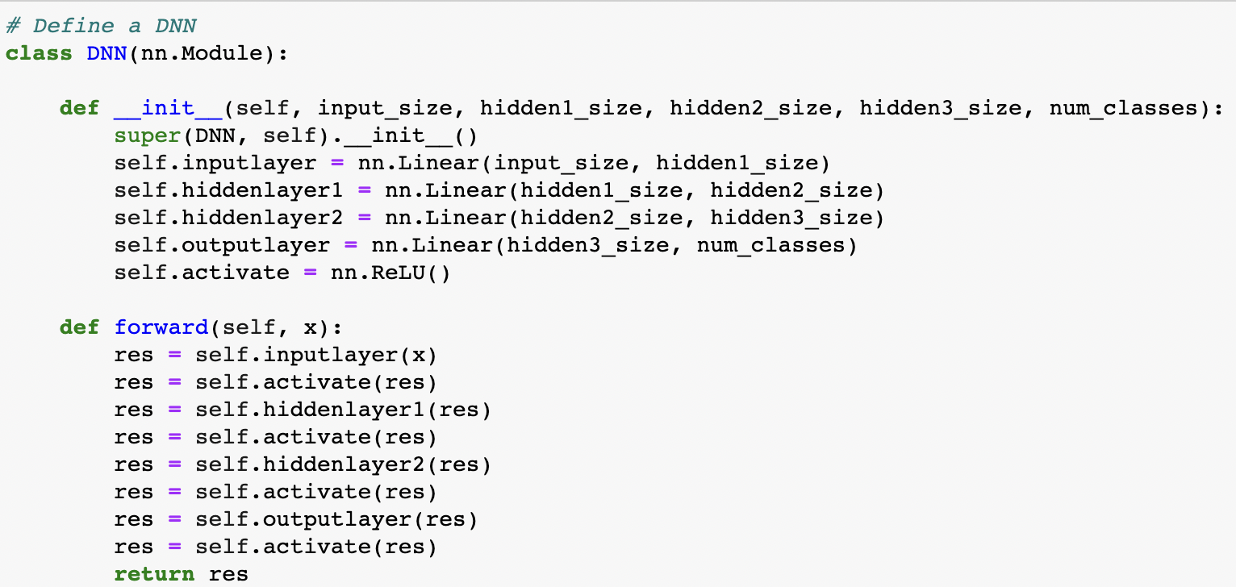

Figure 1 Gestures: DNN Python code

Different from the previous programming assignment, we added multiple layers this time. We build four fully connected layers in our deep neural network and the activate function named “Relu.” We put the activate function after every layer, as you can see above. Compared with the Sigmoid function we used in the last programming assignment, “Relu” has a faster computing speed, saving more time when trying to train the DNN.

Training set configuration

* 1. Typeset Letters: Noiseless
  2. Typeset Letters: Noise-corrupted
  3. American Sign Language gestures: Noiseless

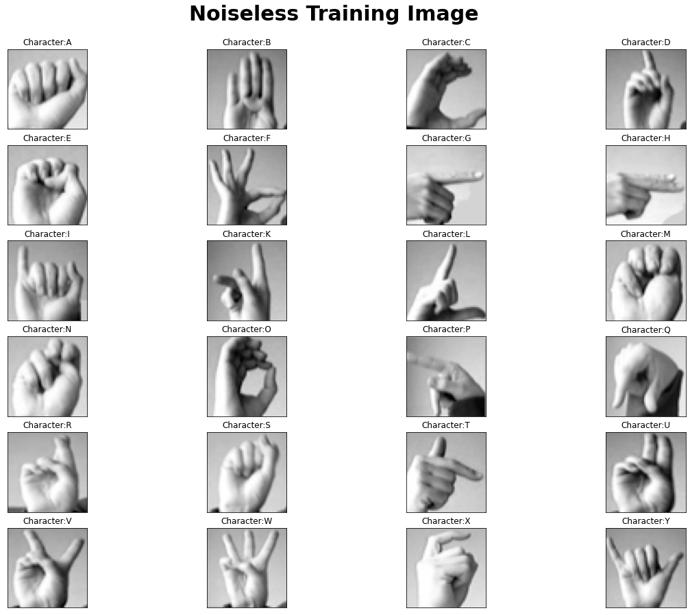

Figure 2 Gesture: Noiseless Training Set

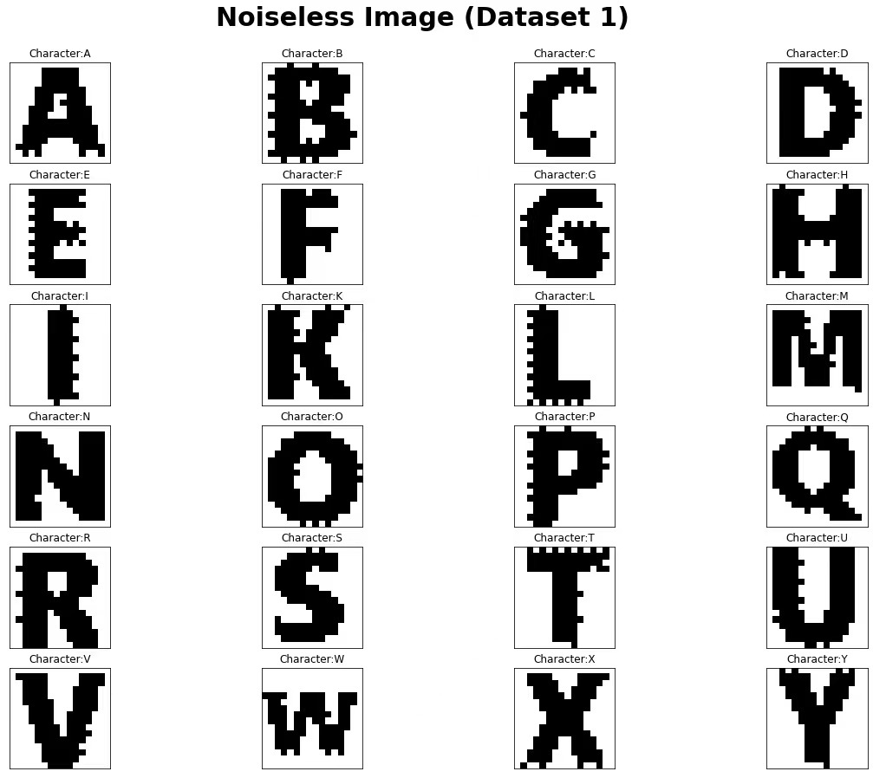

Figure 3 Gesture: Noiseless Training Label

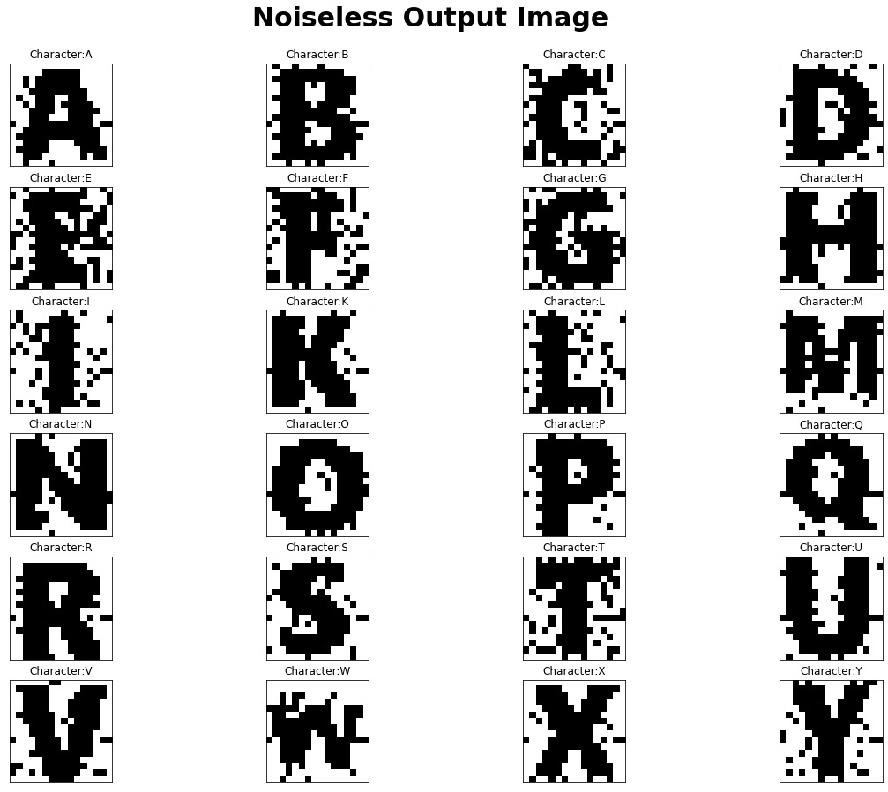

Figure 4 Gesture: Noiseless Training Output

Above is our training set configuration. Based on the requirement, the “Gesture Image” should be our input dataset, and the DNN will output the corresponding “Letter Image.” We used dataset#1 to be the training label in the training process, see *figure 3.* According to the requirement, we should normalize dataset#1 image, namely convert the image into white and black only. Thus, you can see that dataset#1(*figure 3*) has some black pixels attached to the edges of the letters. The number of black pixels increases in the noiseless output image (*figure 4*) because the training process would produce erroneous.

* 1. American Sign Language gestures: Noise-corrupted

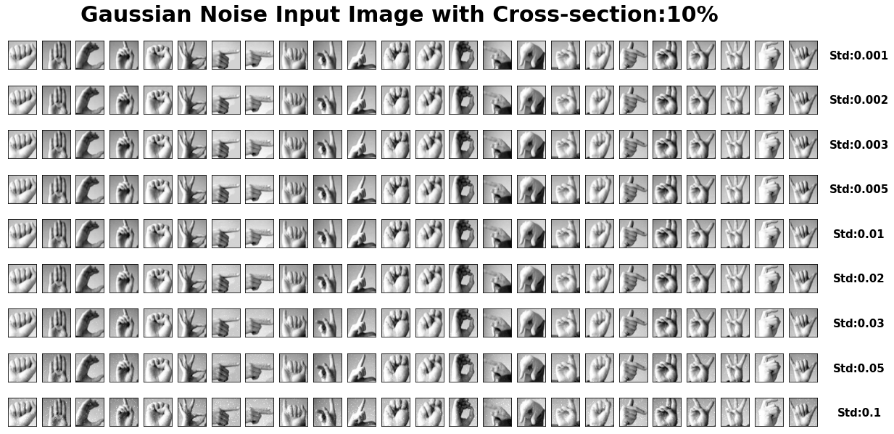

Figure 5 Gesture: Noise-corrupted Input (10%)

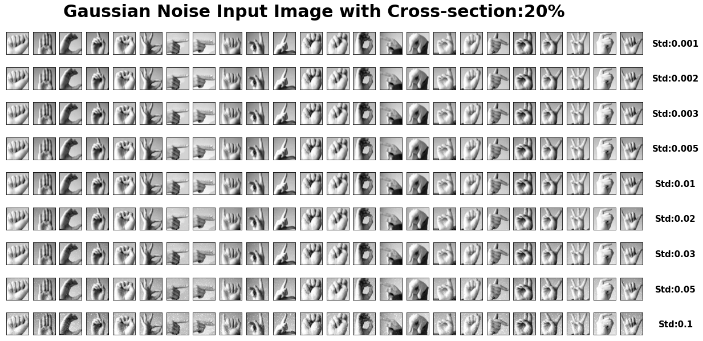

Figure 6 Gesture: Noise-corrupted Input (20%)

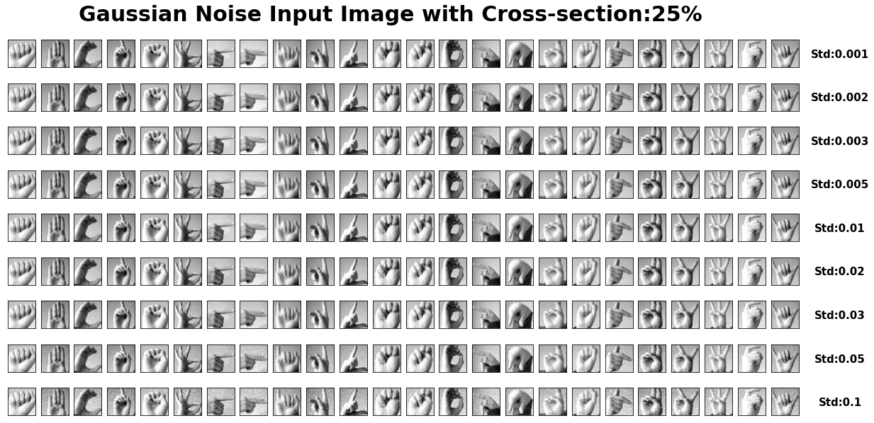

Figure 7 Gesture: Noise-corrupted Input (25%)

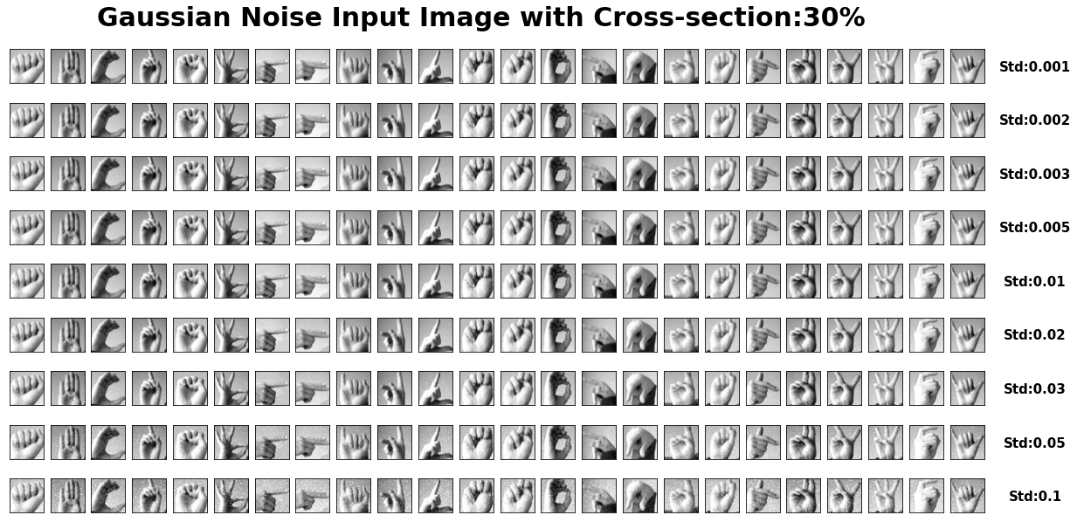

Figure 8 Gesture: Noise-corrupted Input (30%)

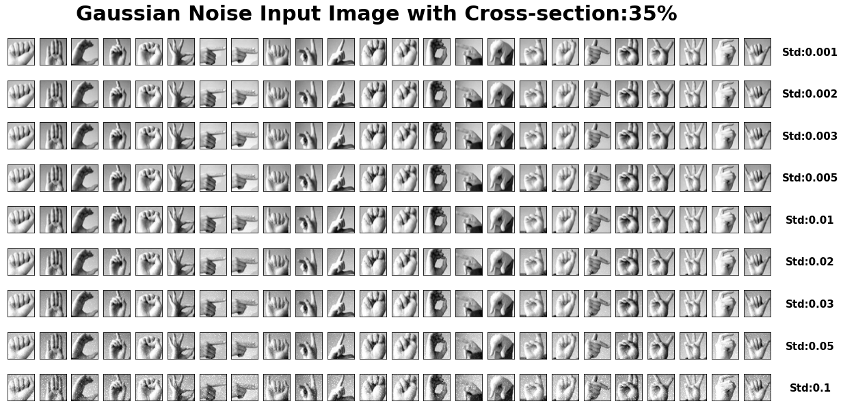

Figure 9 Gesture: Noise-corrupted Input (35%)

*Note: The figure may be too big to fit the document. You can run the code on Jupyter Notebook to gain a better view.*

In the noise-corrupted process, we add the Gaussian Noise with the Standard deviation of 0.001, 0.002, 0.003, 0.005, 0.01, 0.02, 0.03, 0.05, and 0.1, also with the cross-section of 10%, 20%, 25%, 30% and 35%. As a result, you would see there would be a lot of white dots in the image, especially with the standard deviation of 0.1.

1. Visualization of *Fh*& *Ffa: Noiseless* 
   1. Typeset Letters: Scatter Plot and Table of Fh & Ffa
   2. American Sign Language gestures: Scatter Plot and Table of Fh & Ffa

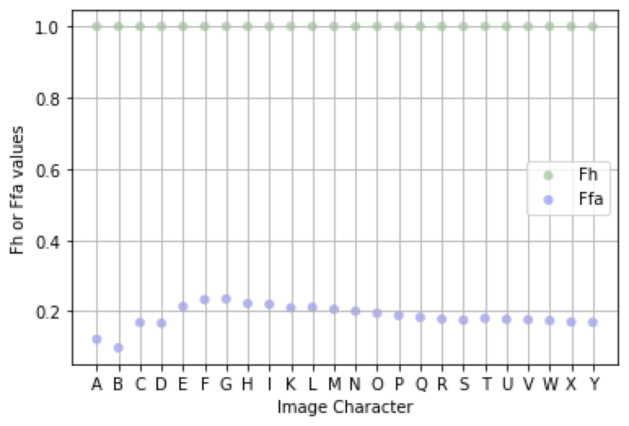

Figure 10 Gesture: Scatter Plot of Fh & Ffa

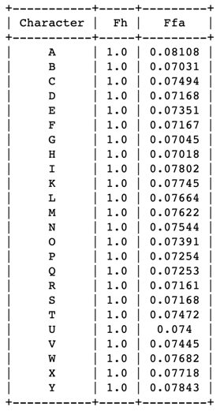

Figure 11 Gesture: Table form of Fh & Ffa

According to *Figure 11* and *Figure 10*, the Fh would be all 1. That means all the black pixels do not become white after the training and testing process. However, there would be a slight fluctuation of Ffa, and this is because some white pixels become black pixels during the training and test process.

1. Pseudocode and Python code for algorithms to compute *Fh & Ffa*
   1. Typeset Letters: Pseudo Code
   2. Typeset Letters: Pseudo Code
   3. American Sign Language gestures: Pseudo Code

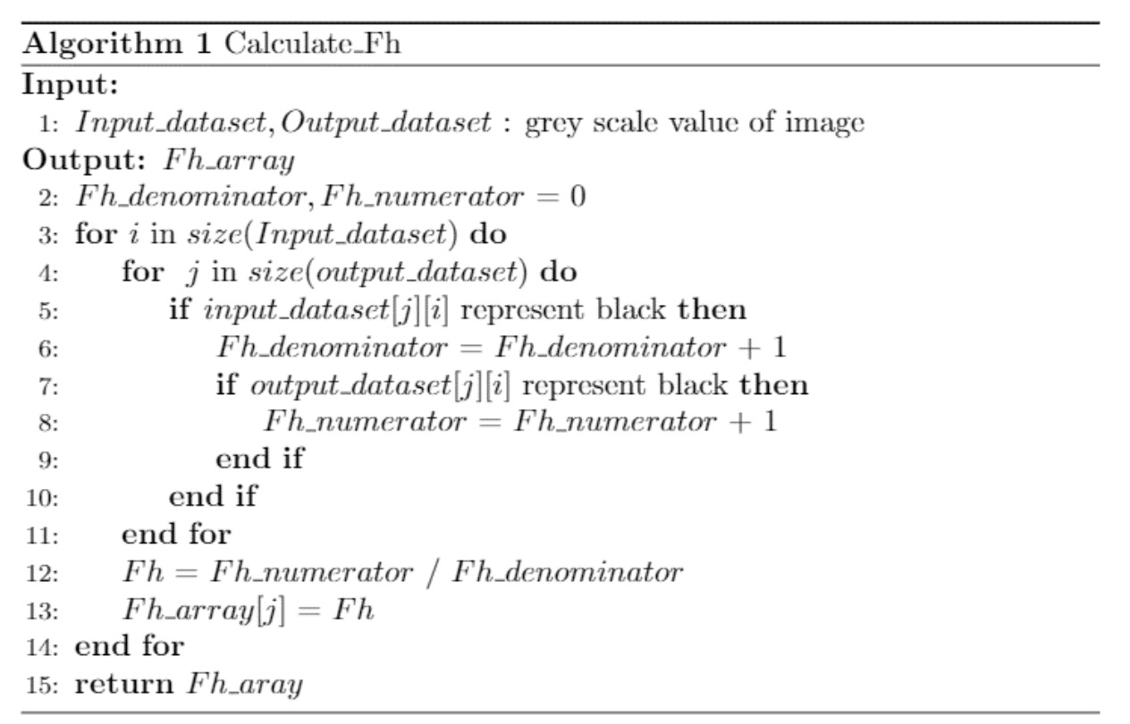

Figure 12 Pseudocode for Fh

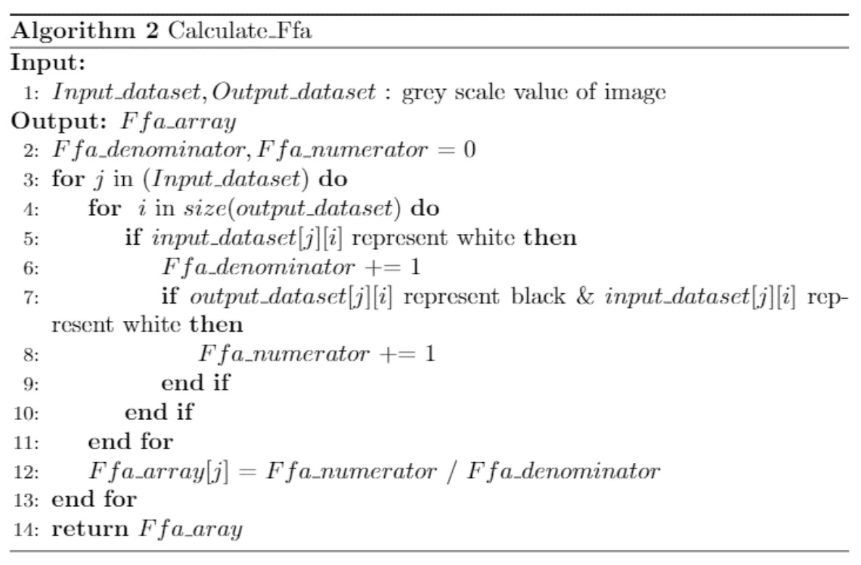

Figure 13 Pseudocode for Ffa

* 1. American Sign Language gestures: Python Code

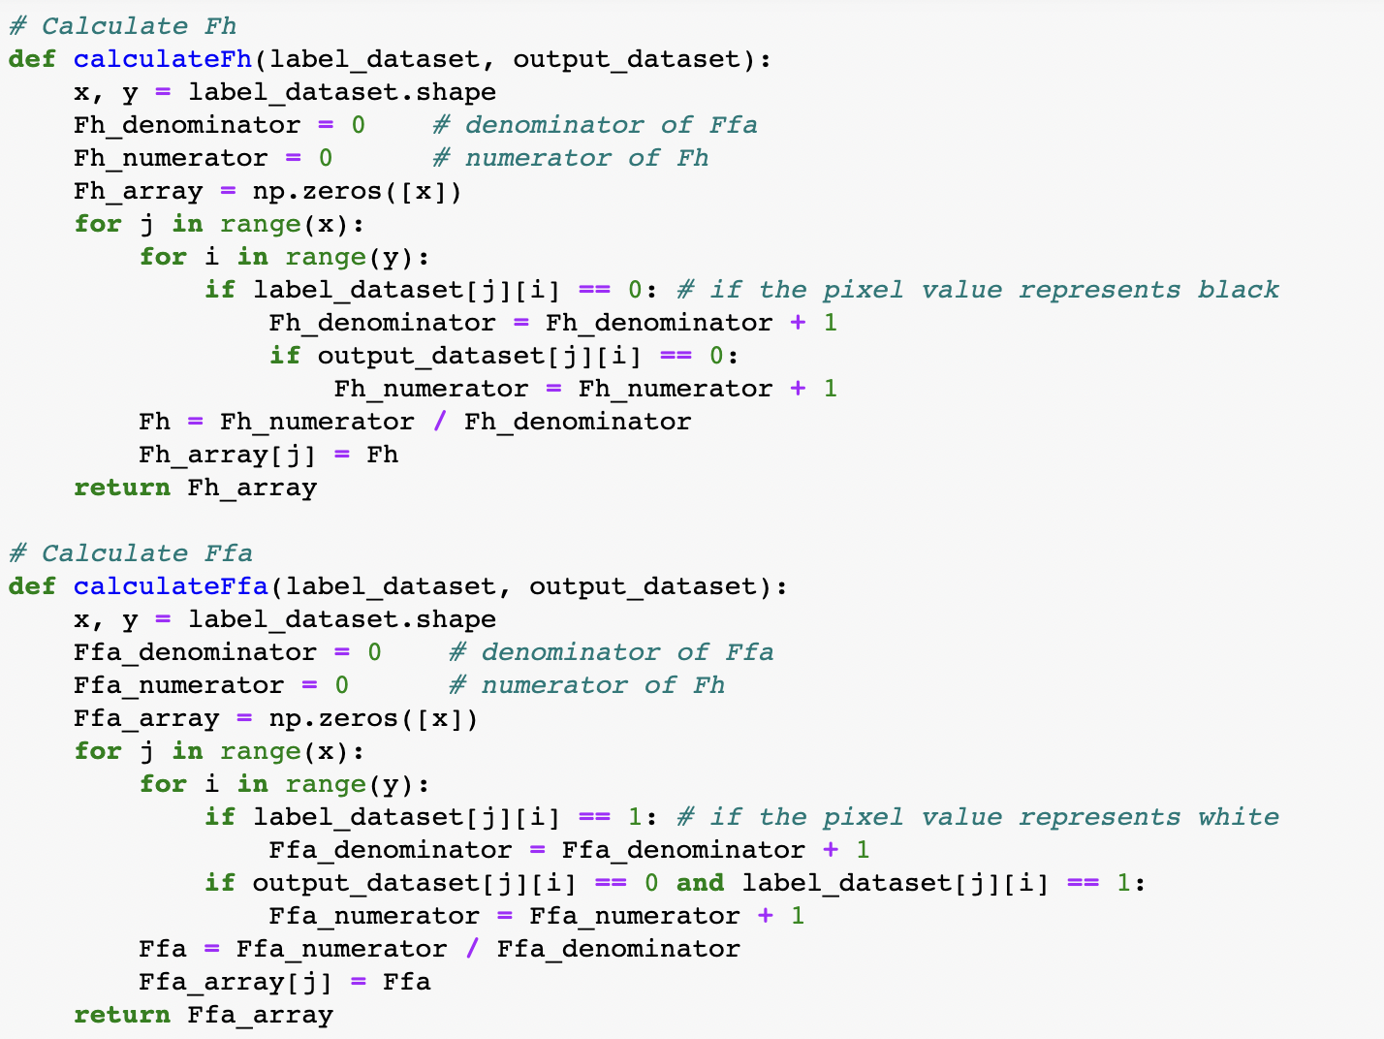

Figure 14 Gesture: Python code for Computing Ffa & Fh

1. Visualization of *Fh*& *Ffa:* Noise-corrupted

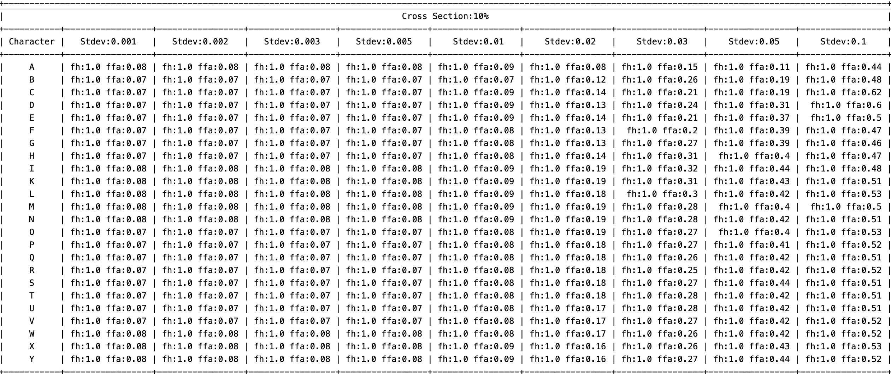

Figure 15 Gesture: Noise-corrupted Ffa & Fh (10%)

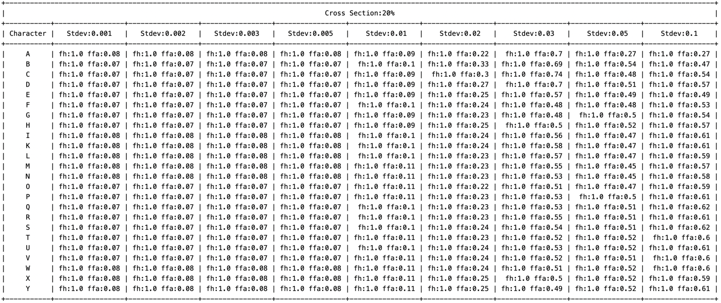

Figure 16 Gesture: Noise-corrupted Ffa & Fh (20%)

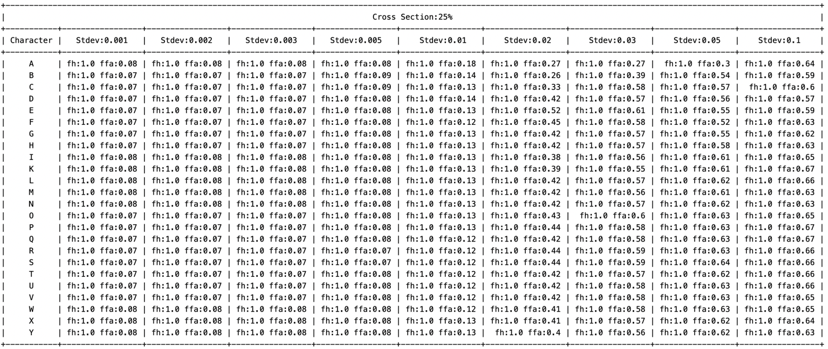

Figure 17 Gesture: Noise-corrupted Ffa & Fh (25%)

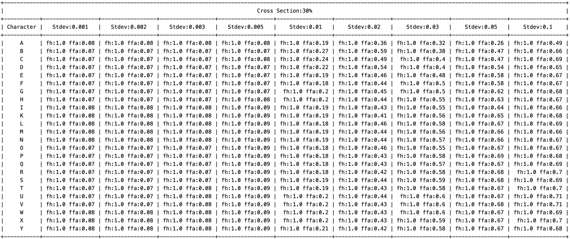

Figure 18 Gesture: Noise-corrupted Ffa & Fh (30%)

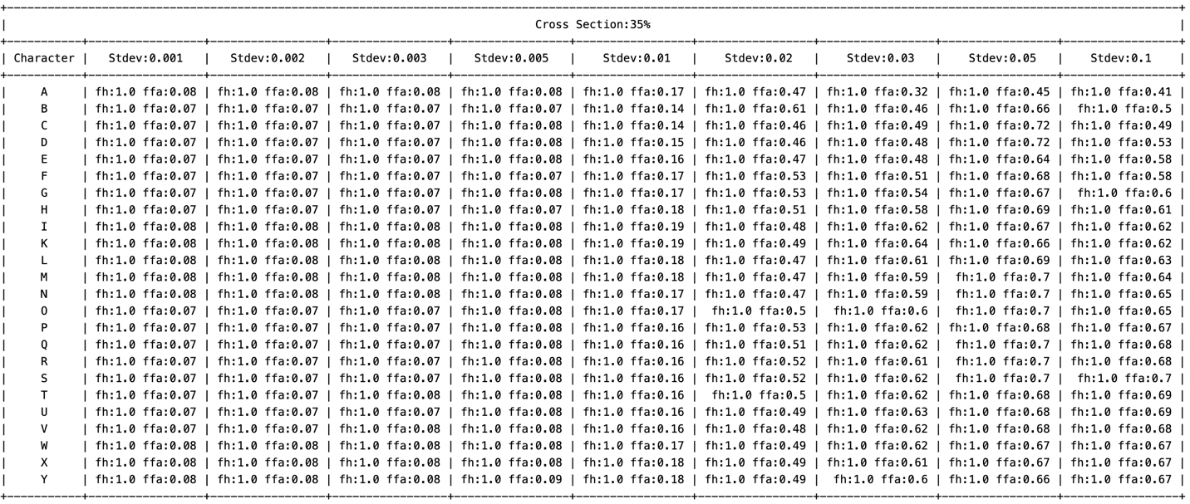

Figure 19 Gesture: Noise-corrupted Ffa & Fh (35%)

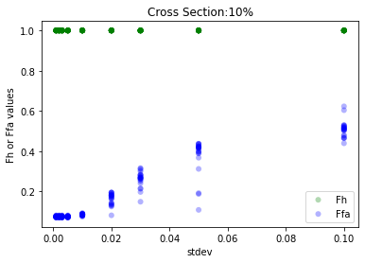 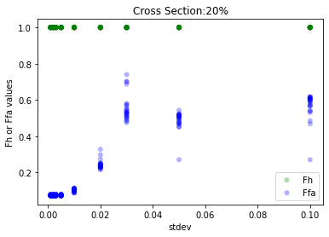

Figure 20 Gesture: Noise-corrupted Scatter plot of Ffa & Fh (10% & 20%)

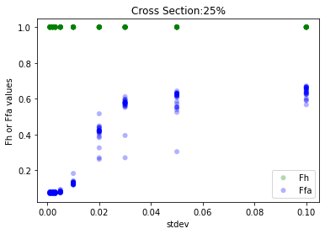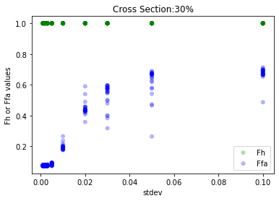

Figure 21 Gesture: Noise-corrupted Scatter plot of Ffa & Fh (25% & 30%)

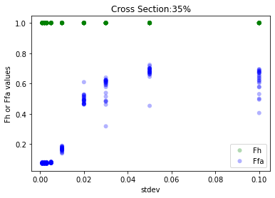

Figure 22 Gesture: Noise-corrupted Scatter plot of Ffa & Fh (35%)

According to the scatter plot and table of Ffa, we can conclude that the Ffa value would increase under increasing cross-section and standard deviation of Gaussian Noise.

1. Discussion
   1. Workflow of Typeset Recognition
   2. Questions & Answers in Step 4c
   3. Workflow of Gesture Recognition

To present our full programming, we would like to present the workflow at first, see *Figure 23* below,

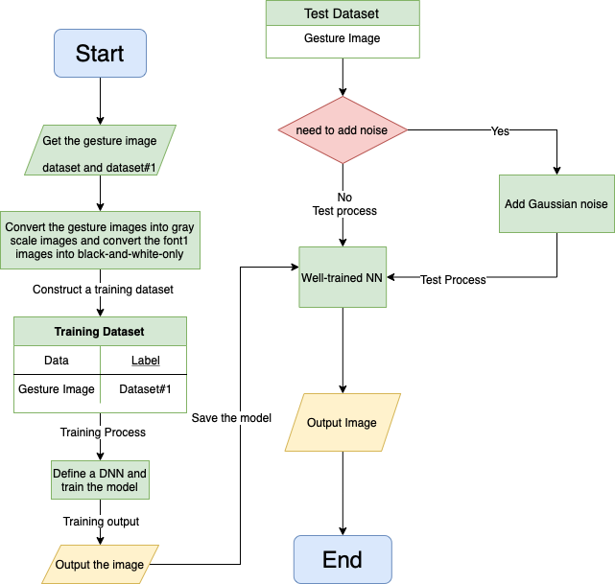

Figure 23 Gesture: Workflow